My headache diary Name ……………………….
Please record all headaches not just the bad ones. Complete as fully as you can and bring this sheet to your follow up appointment

Date and time started | Date and time finished | Pain level (please use visual scale) | Where do you feel your headache? | Trigger or warning signs? | Medication used  How many times? | Other symptoms at the time (e.g. vomiting)
 |  |  | 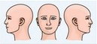
 |  |  | 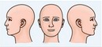
 |  |  | 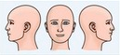
 |  |  | 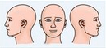
 |  |  | 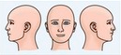
 |  |  | 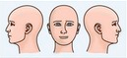
 |  |  | 